**TEAM 7 RESOURCES – CST Participants**

1. Agenda

|  |  |  |  |
| --- | --- | --- | --- |
| Timeslot | Tuesday, Sept 15, 2020 | Wednesday, Sept 16, 2020 | Thursday, Sept 17, 2020 |
| 7:30 AM - 10:45 AM |  | Team Hacking | Team Hacking |
| 10:45AM – 11:15 AM | Opening + Welcome |
| 11:15 AM - 12:15 PM | Team Hacking |
| 12:15 PM - 1:00 PM | Break | | |
| 1:00 PM – 3:00 PM | Team Hacking | Team Hacking | Team Hacking |
| 3:00 PM - 3:30 PM | Closing Remarks |

1. Team Assignments

|  |  |  |  |  |
| --- | --- | --- | --- | --- |
| **Role** | **Name** | **Hacker** | **Skillmeup** | **Password** |
| Coach | Mara Preotescu |  |  |  |
| Participant | Jose Arias | 1 | 86129-98acf-7@skillmeup.com | Password123 |
| Participant | Bob Jacobs | 2 | 86129-98acf-7@skillmeup.com | Password123 |
| Participant | Junior Sawney | 3 | 86129-98acf-7@skillmeup.com | Password123 |
| Participant | Tom Mills | 4 | 86129-98acf-7@skillmeup.com | Password123 |
| Participant | Kyu Choi | 5 | 86129-98acf-7@skillmeup.com | Password123 |
| Participant |  | 6 | 86129-98acf-7@skillmeup.com | Password123 |

3. Azure Portal Login Instructions

1. **Go to**[**aka.ms/ohportal**](https://openhacks.azurewebsites.net/) **(go to next tab – OpenHack Portal)**
2. All participants (up to 6 per team) log in with their assigned team credentials.

* **Login**: 86129-98acf-7@skillmeup.com
* **Password**: Password123

1. Each participant then uses one of the 6 hacker accounts to log into the Azure portal and hack through the challenges - you can post in chat which hacker account you are using so your teammates know!

Logging into the portal

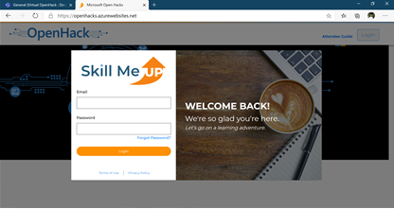

Azure portal logins (**example**)

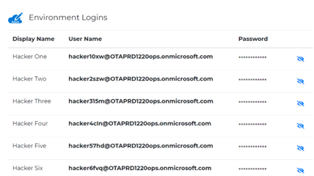

4. Navigating the Opsgility Portal

Reference the Opsgility portal user guide - <https://aka.ms/AttendeePortalGuide>

5. Submitting Feedback

**Feedback is critical to improve the OpenHack program and related products**, so please provide technical feedback (product-related: documentation, tech blocker, feature request, business blocker) & program feedback (OpenHack content-related: update to challenge content or OpenHack program).

* Click "Provide Feedback" tab --> Add Feedback --> Submit
* Make sure to include screenshots and / or code snips

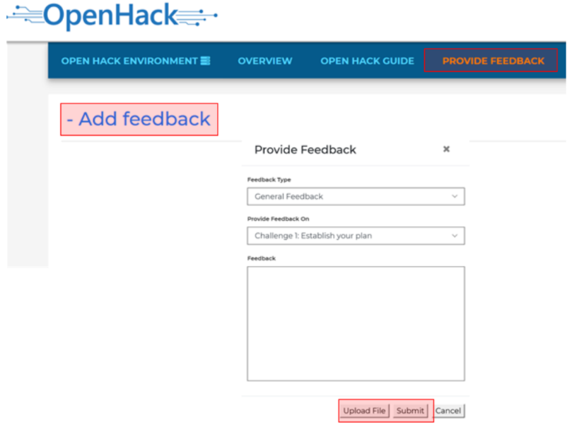

6. Survey Link [AI-Powered Knowledge Mining_US DTA_Survey](https://www.microsoftevents.com/profile/11388449)

7. Reference General Resources

For other information and resources, please reference the [General Resources](https://microsoftapc.sharepoint.com/:w:/t/OpenHackTemplate2/Edd95cJw-yZIuUyrhCYs6CwBYVi1itXiFXB-daPYgqZsEw?e=bdQcmY) under General Channel